**MENSURATION (I)**

**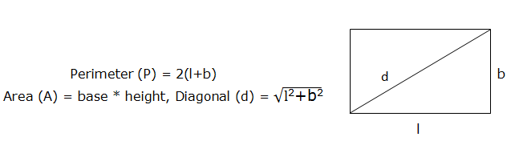  
  
2. Rhombous:   
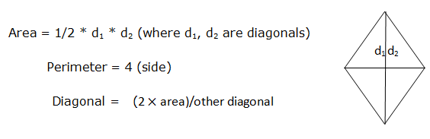  
  
3. Square : All sides, diagonals, angles are equal.  
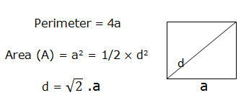  
4. Parallelgram : Two opposite sides are parallel AD//BC and AB//DC  
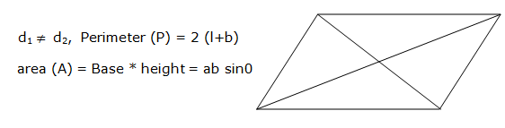  
  
5. Triangles :  
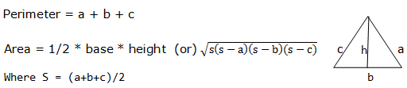  
  
6. Trapezium : One porallel side equal AB//CD  
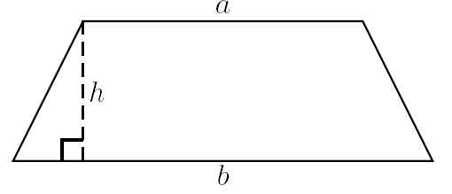  
Area = 1/2 h (a + b) = 1/2 (Sum of Parallel sides × distance between them)  
Sum of the Sides  
  
7. Equilateral triangle : :  
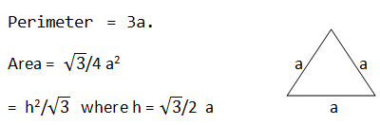  
  
  
1. Prism :   
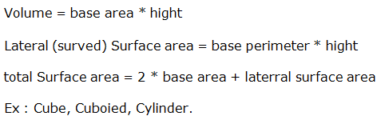  
2. Cube :   
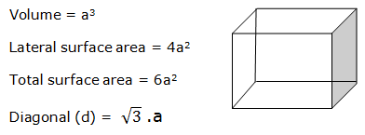  
3. Cuboid :   
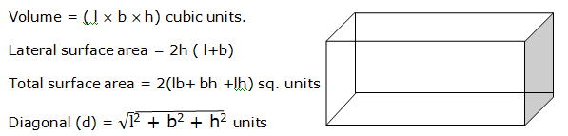  
  
4. Cylinder :   
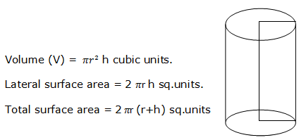  
  
5. Cone :   
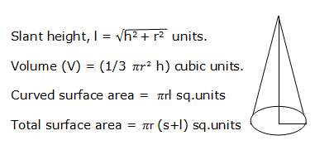  
6. Sphere :   
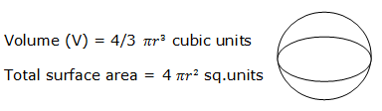  
7. Hemi Sphere :   
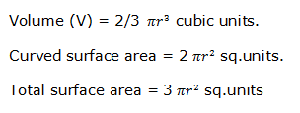  
  
  
1. Circle :  
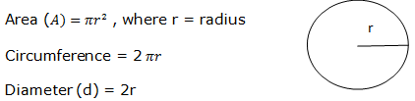  
  
  
2. Semicircle :  
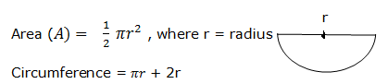  
  
  
3. Sector :  
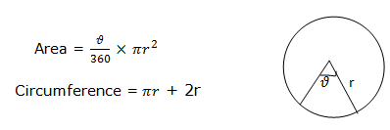**

1. Find the area of a triangle whose sides are 14cm, 48cm and 50 cm?

a) 672cm2 b) 336cm2 c) 350cm2 d) 700cm2

2. The perimeter of an isosceles triangle is 36cm. If one of the equal sides is 13cm, find the area of the triangle?

A) 60cm2 b) 30cm2 c) 30√2cm2 d) 36√2cm2

3. Find the area of a right angled triangle whose hypotenuse is 16cm and one of the angles is 30o?

a) 18√2 sq.cm b) 24√5 sq.cm c) 36√5 sq.cm d) None

4. If the altitude of a triangle is increased by 40% and the base is decreased by 15% then find the % change in its area?

a) 21% increase b) 21% decrease c) 19% increase d) 19% decrease

5. Find the two perpendicular sides of a right angled triangle whose hypotenuse is 68cm and the perimeter 160cm?

a) 32cm, 60cm b) 36cm, 56cm c) 40cm, 52 cm d) Can’t be determined

6. Find the perimeter of an equilateral triangle whose are is 3 times that of a rectangle of length 9cm and width 1/√3cm.?

a) 18cm b) 24cm c) 30cm d) 16cm

7. If the perimeter of a rhombus is 52cm and one of its diagonal is 10cm, then find its area in sq.cm?

a) 154 b) 168 c) 120 d) 150

8. Find the height of a trapezium whose parallel sides are 14cm and 8 cm and area is 154 sq.cm.

a) 7cm b) 14cm c) 21cm d) 27cm

9. Find the perimeter of a square inscribed in a circle of radius 7cm.

a) 14√2cm b) 21√2cm c) 28√2cm d) 35√2cm

10. If a path 3 m wide is laid all round and outside a field of dimensions 25m x 15m, then find the area of the path?

a) 276 sq m b) 256 sq m c) 240 sq m d) 266 sq m

11. A goat is tied to one corner of a field of dimensions 16m x 10m with a rope 7m long. Find the area of the field that the goat can graze?

a) 77 sq m b) 38.5 sq m c) 44 sq m d) 75 sq m

12. If the length of a rectangle is increased by 20% and the breadth is decreased by 10%, the find the percentage change in its area?

A) 8% decrease b) 15% increase c) 8% increase d) 15% decrease

13. A square shaped floor has a side measuring 16m. How many tiles measuring 0.4m x 2m are needed to cover the wall?

a) 32 b) 160 c) 320 d) 180

14. The wheel of a cycle covers 1100m by making 175 revolutions. Find the diameter of the wheel?

a) 1m b) 2m c) 3cm d) 4m

15. What is the circumradius of a triangle with sides 10cm, 10cm and 12cm?

a) 6.25cm b) 8.5 cm c) 7.33 cm d) 10.2cm

16. The area of an equilateral triangle is 36√3 sq.cm. Find its height? (in cm)

a) 4√3 b) 3√3 c) 8√3 d) 6√3

17. Find the total surface area and volume of a rectangular box which is 7m long, 5m wide and 6m high?

a) 130m2, 180m3 b) 130m2, 210m3 c) 154m2, 180m3 d) 214m2, 210m3

18. Find the side of a cube formed by melting a cuboid of dimensions 36cm x 24cm x 16cm

a) 16cm b) 24cm c) 28cm d) 30cm

19. A hall is 15m long and 9m wide. The height of the hall is 12m. Find the cost of painting the walls at Rs.2.5 per sq m approximately?

a) Rs.2000 b) Rs.2160 c) Rs.1440 d) Rs.3600

20. Find the curved surface area and the total surface area of a cone whose slant height is 7m and radius 3.5m.

a) 70m2, 110m2 b) 77m2, 115.5m2 c) 77m2, 125m2 d) None

21. A solid rectangular box of dimensions 16cm x 12cm x 11cm is melted to form lead balls of dimeter 4cm. Find the no. of lead balls formed?

a) 63 b) 74 c) 62 d) 50

22. How many bricks are needed to complete a wall 15m x 12m x 10cm using bricks 24cm x 25cm x 10cm thick, if 2/3rd of the wall is already built?

a) 1200 b) 1100 c) 1000 d) 8000

23. Find the canvas needed to cover a conical tent whose slant height is 13m and height √120m.

a) 286m2 b) 308m2 c) 264m2 d) 364m2

24. What is the length of the longest rod that can be kept in a room of length 12m, breadth 4m and height 3m.

a) 13m b) 14m c) 15m d) 12m

25. Find the curved surface area and the total surface area of a cylinder whose height is 21m and radius of the base is 3.5m.

a) 441m2, 530m2 b) 539m2, 462m2 c) 462m2, 539m2 d) None

26. The total surface area of a hemisphere is equal to that of a sphere. Find the ratio of the volume of the sphere to that of the hemisphere?

a) 3√3 : 8 b) 3√3 : 16 c) 3√3 : 4 d) 3√3 : 32

27. A rectangular polygon has 20 diagonals. Find the measure of an exterior angle?

a) 30o b) 40o c) 20o d) 45o

28. The sum of the circumference of two concentric circles is 66cm. The area of the region in the shape of a ring between them is 115.5 sqcm. Find the width of that region (in cm).

a) 7 b) 3.5 c) 1.75 d) 5.25

29. A cone and a hemisphere have equal volumes as well as equal radii. The height of the cone is 4cm more than its radius. Find its radius?

a) 2cm b) 4cm c) 6cm d) 3cm

30. A circle is inscribed in a square. A square is inscribed in that circle. Another circle is inscribed in this square. Find the ratio of the areas of the outer square and the inner most circle.

a) 14:11 b) 21:11 c) 28:11 d) 42:11

31. In a rectangle if the length is increased by 2cm and the breadth is reduced by 2cm, its area gets reduced by 28m2. If the length is reduced by 1m and the breadth is increased by 2m, its area increased by 33m2. Find the area of the rectangle initially?

a) 350m2 b) 260m2 c) 400m2 d) 253m2

32. If 3 cubes of diagonals 6√3cm, 8√3cm, 10√3cm are melted to form a new cube, find the length of the diagonal of the new cube?

a) 10√3cm b) 11√3cm c) 12√3cm d) 34√3cm

33. The area of a regular hexagon whose perimeter is 12cm is

a) 6√2cm 2 b) 8√3cm2 c) 8√2cm2 d) 6√3cm2

34. The radius of the base of a conical tent is 12cm and its height is 5cm. Find the area of the canvas required to frame the tent?

a) 156∏cm2 b) 168∏cm2 c) 146∏cm2 d) 136∏cm2

35. The curved surface area of a cylinder is 4 times its base area. Find the ratio of the radii of its base and height?

a) 2:1 b) 4:1 c) 1:4 d) 1:2

36. The length, breadth and height of a room are 12m, 8m, and 3m respectively. What is the area of the four walls of the room?

a) 122m2 b) 118m2 c) 120m2 d) 116m2

37. The ratio of the radii of 2 cones is 2:3 and that of their volumes is 8:9. What is the ratio of their heights?

a) 3:2 b) 2:1 c) 5:4 d) 4:3

38. If a cube of side 12cm is cut into smaller cubes of side 2cm, then the smaller cubes formed is

a) 64 b) 196 c) 125 d) 216

39. A swimming pool 100m long and 40m wide is 1m deep at the shallow end and 5m at the deep end. Find the volume of water contained in the pool?

a) 8000m 3 b) 120003 c) 15000m3 d) 18000m3

40. What is the area of a cyclic quadrilateral of which the sides are 5cm, 6cm, 7cm and 8cm?

a) 4√105cm2 b) 3√105cm2 c) 2√105cm2 d) √105cm2